**Geography “I Can” Statements**

C:\Program Files\Microsoft Office\MEDIA\CAGCAT10\j0335112.wmf

**The Basics of Geography -Chapters 1 - 3**

**Vocabulary to know:**

Absolute location Cartographer Chemical weathering Climate

Coniferous Deciduous Delta Drainage basin

Earthquake El Niño Equator Equinox

Erosion Fault Geographic Information Systems (GIS) Geography

Glaciation Globe Greenhouse effect Hemisphere

Landform Landsat Latitude Longitude

Map Map projection Mechanical weathering Permafrost

Precipitation Prime meridian Rain forest Rain shadow

Ring of Fire Savanna Solstice Steppe

Tectonic plate Topographic map Topography Tundra

Weather Weathering

**I CAN…**

1. I can explain the five themes of geography and give an example of each.
2. I can explain the three branches of geography.
3. I can describe basic geographic tools and technology.
4. I can compare the advantages and disadvantages of maps and globes.
5. I can understand and interpret the different elements of a map.
6. I can understand and interpret different types of maps and map projections.
7. I can describe the earth’s structure.
8. I can identify the characteristics of oceanic and continental landforms.
9. I can describe the internal forces that shape the Earth.
10. I can describe the external forces that shape the Earth.
11. I can explain how annual changes in the relationship between the Earth and Sun cause the seasons.
12. I can identify the factors that influence weather and describe the main types of extreme weather.
13. I can explain the factors that influence the climate of a region and the factors that define climate regions.
14. I can describe the effects of El Niño, La Niña, and global warming.
15. I can describe the four major types of vegetation found throughout the world.
16. I can describe ways in which people have altered the environment.

**Geography “I Can” Statements**

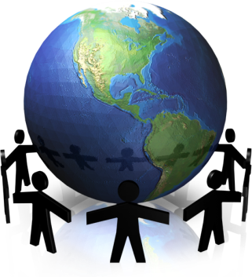

**Human Geography -Chapter 4**

**Vocabulary to know:**

Acculturation Birthrate Carrying capacity Central Business District

City Command economy Communism Cultural hearth

Culture Democracy Dialect Diffusion

Economy Economic system Ethnic group Fertility rate

GDP GNP Infant mortality rate Infrastructure

Innovation Landlocked Metropolitan area Mortality rate

Nation Nation-state Natural resources Per capita income

Population density Population pyramid Push-pull factors Rate of natural increase

Relative location Relief Religion Society

Suburb State Urban geography Urbanization

**I CAN…**

1. I can define culture and explain its impact.
2. I can explain how culture changes and spreads.
3. I can describe how language unites and divides people and how it changes and spreads.
4. I can identify and define three categories of religion.
5. I can describe the world’s major religions.
6. I can describe the distribution of the world’s population and explain the factors involved in the world’s population growth.
7. I can describe factors that influence population density and carrying capacity.
8. I can define the three categories of governments and identify the main types of regional political systems.
9. I can explain the most important geographic characteristics to describe a county and distinguish between natural and artificial boundaries.
10. I can explain how urban areas develop.
11. I can identify the basic land-use patterns found in all cities and describe the function of cities.
12. I can identify the four basic types of economic systems.
13. I can define the four levels of economic activity.
14. I can distinguish among renewable, non-renewable, and inexhaustible resources.
15. I can explain the differences between developing and developed nations.